WATER JUG PROBLEM

Aim
To solve the Water Jug Problem using Python by finding the sequence of steps required to obtain the required amount of water.
Objective
- To understand the Water Jug Problem.
- To perform fill, empty, and transfer operations.
- To obtain the required quantity of water in one of the jugs.
- To display the sequence of steps leading to the solution.
Algorithm
- Start the program.
- Read the capacities of Jug 1 and Jug 2.
- Read the target amount of water.
- Fill Jug 2 completely.
- Pour water from Jug 2 to Jug 1 until Jug 1 is full.
- Empty Jug 1.
- Transfer the remaining water from Jug 2 to Jug 1.
- Refill Jug 2.
- Pour water from Jug 2 to Jug 1 until the target amount is obtained.
- Display the steps.
- Stop the program.

Code:
print("=" * 60)
print(" ARTIFICIAL INTELLIGENCE LAB")
print(" Experiment: Water Jug Problem")
print(" Name : Vinnarasu R")
print(" Reg No : 192411040")
print("=" * 60)

j1 = int(input("Enter capacity of Jug 1: "))
j2 = int(input("Enter capacity of Jug 2: "))
target = int(input("Enter target amount: "))

a = 0
b = 0

print("\nSteps:")

while b != target:
if a == 0:
a = j1
elif b == j2:
b = 0
else:
t = min(a, j2 - b)
a -= t
b += t

print("Jug1 =", a, "Jug2 =", b)

print("\nTarget Reached!")
Output:
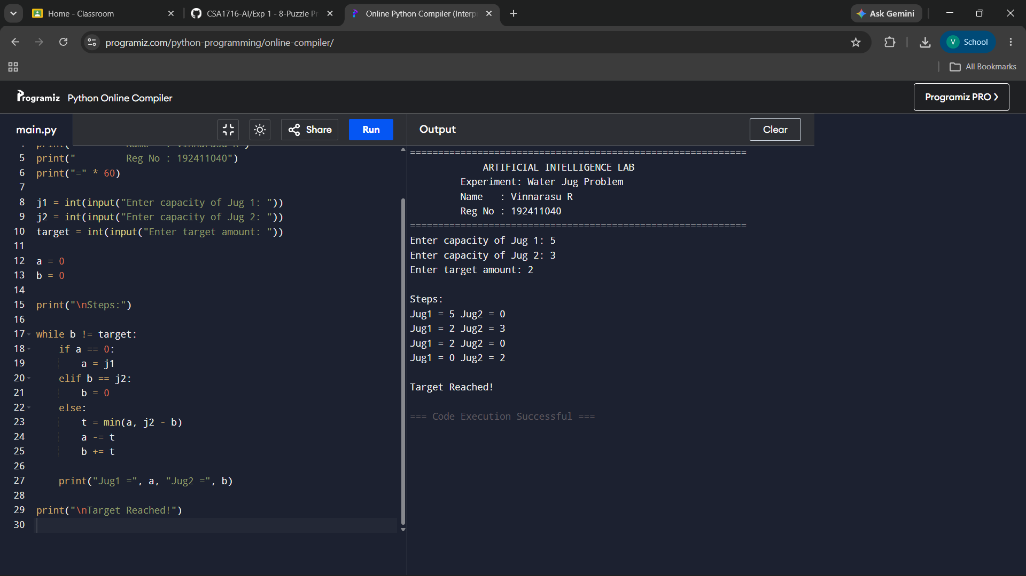
Result:
The Water Jug Problem was implemented successfully in Python. The program accepted the capacities of the two jugs and the target amount as input, performed the fill, empty, and transfer operations, and successfully reached the required amount of water while displaying each step of the solution.

